|  |  |  |  |  |  |  |
| --- | --- | --- | --- | --- | --- | --- |
| *k* | *dm*= 0.25 | *dm* = 0.5 | *dm* = 1.0 | *dm* = 1.5 | *dm* = 2.0 | *dm* = 2.5 |
| 4 | 1,48 | 1,91 | 3,46 | 4,1 | 4,56 | 4,8 |
| 5 | 1,53 | 2,31 | 4,39 | 5,62 | 6,07 | 6,25 |
| 6 | 1,81 | 2,84 | 4,6 | 6,86 | 8,03 | 8,71 |
| 7 | 1,95 | 2,99 | 6,42 | 9,04 | 11,14 | 11,57 |
| 8 | 2,13 | 3,57 | 7,87 | 12,03 | 14,69 | 15,62 |
| 9 | 2,29 | 4,99 | 10,07 | 17,26 | 20,1 | 21,07 |
| 10 | 3,15 | 5,07 | 13,68 | 22,19 | 26,64 | 29,42 |
| 11 | 2,66 | 5,26 | 17,88 | 31,35 | 39,97 | 39,56 |
| 12 | 3,01 | 7,2 | 22,06 | 36,78 | 54,74 | 60,62 |

**Таблица Эффективности для b1,b2=0.2 АР(2)**

**Таблица Эффективности для b1=0.2 АР(1)**

|  |  |  |  |  |  |  |
| --- | --- | --- | --- | --- | --- | --- |
| *k* | *dm*= 0.25 | *dm* = 0.5 | *dm* = 1.0 | *dm* = 1.5 | *dm* = 2.0 | *dm* = 2.5 |
| 4 | 1,99 | 2,98 | 4,17 | 4,65 | 5,62 | 5,24 |
| 5 | 1,92 | 2,71 | 6,87 | 6,85 | 8,13 | 8,11 |
| 6 | 2,74 | 2,84 | 7,99 | 8,08 | 12,74 | 11,89 |
| 7 | 2,87 | 3,12 | 9,06 | 16,8 | 18,13 | 17,27 |
| 8 | 2,82 | 5,4 | 14,22 | 24,5 | 30,59 | 30,36 |
| 9 | 1,41 | 4,01 | 19,69 | 27,17 | 39,66 | 48,27 |
| 10 | 5,55 | 15,89 | 28,07 | 46,84 | 56,88 | 65,75 |
| 11 | 2,92 | 15,61 | 37,91 | 55,32 | 110,16 | 78,97 |
| 12 | 4,6 | 7,52 | 43,49 | 55,96 | - | 93,73 |

**Таблица Эффективности для ГФ(3)**

|  |  |  |  |  |  |  |
| --- | --- | --- | --- | --- | --- | --- |
| *k* | *dm*= 0.25 | *dm* = 0.5 | *dm* = 1.0 | *dm* = 1.5 | *dm* = 2.0 | *dm* = 2.5 |
| 4 | 1,75 | 2,08 | 2,24 | 2,21 | 2,23 | 2,23 |
| 5 | 1,55 | 2,31 | 2,29 | 2,32 | 2,31 | 2,31 |
| 6 | 1,89 | 2,38 | 2,37 | 2,38 | 2,37 | 2,37 |
| 7 | 1,49 | 2,47 | 2,46 | 2,48 | 2,47 | 2,46 |
| 8 | 2,3 | 2,53 | 2,52 | 2,53 | 2,51 | 2,51 |
| 9 | 1,87 | 2,62 | 2,58 | 2,56 | 2,58 | 2,6 |
| 10 | 2,06 | 2,72 | 2,71 | 2,71 | 2,72 | 2,67 |
| 11 | 2,48 | 2,61 | 2,75 | 2,78 | 2,79 | 2,78 |
| 12 | 2,53 | 2,88 | 2,78 | 2,85 | 2,85 | 2,9 |

**АКФ для бинарного сигнала, АР(1), b1=0.2**

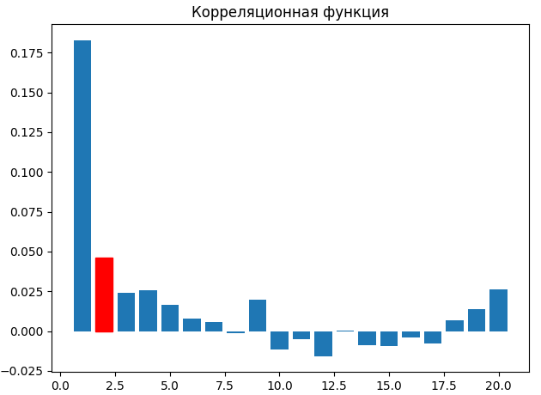

Тау mk = 2

Тау к = 0.22933359315034563

**АКФ для непрерывного сигнала, АР(1), b1=0.2**

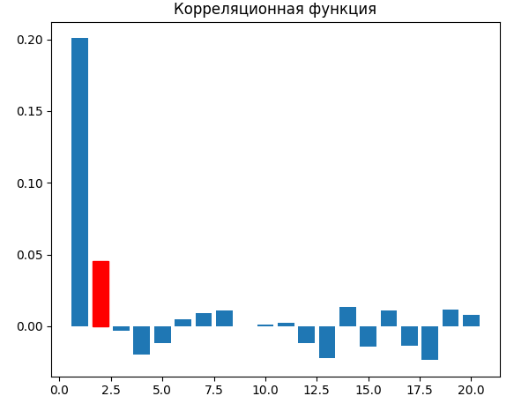

Тау mk = 2

Тау к = 0.2462310582509026

**АКФ для бинарного сигнала, ГФ(3)**

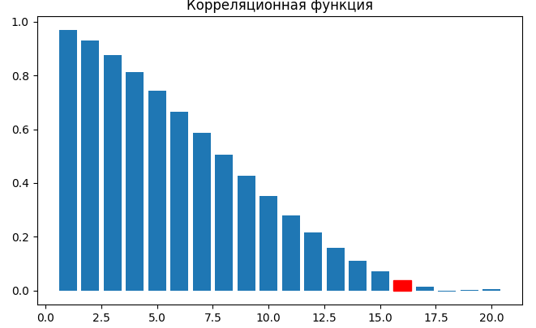

Тау mk = 16

Тау к = 7.736415595313354